**Business Modeling**

**Discipline Document**

**INF-F Analysis and Software Design**

**Project: HHS Term Planning**

**Date: 14-3-2014**

**Owner: Lustenhouwer, Wim. Van Damme, Djastin**

**Version: 1.0**

**Document History**

**Revision History**

|  |  |  |
| --- | --- | --- |
| **Version** | **Revision date** | **Summary of changes** |
| 0.1 | 20-2-2014 | Business Process Diagram added |
| 0.2 | 12-3-2014 | Updated document |
| 0.3 | 12-3-2014 | Added business rules |
| 0.4 | 13-3-2014 | Updated document |
| 1.0 | 14-3-2014 | Final version |

**Distribution**

This document is intended for:

|  |  |  |  |
| --- | --- | --- | --- |
| **Name** | **Function** | **Date of issue** | **Version** |
| van Aalten, Jos | Client | 14-3-2014 | 1.0 |
| Maas, Juul | Business consultant | 14-3-2014 | 1.0 |
| Lustenhouwer, Wim | Project Manager | 14-3-2014 | 1.0 |
| van Damme, Djastin | Project Co-Manager | 14-3-2014 | 1.0 |

**Table of Contents**

1. Introduction 4

2. Business Use Case Diagram 4

3. Chosen Business Process 4

3.1. Business Use Case Specification 4

3.2. Business Process Diagram 5

3.3. Business Activity Diagram 6

4. Business Rules 6

# Introduction

As the INF-F project consists of replacing current business processes, it is imperative to make a complete overview of said business. The business modeling discipline document serves as a general overview of the part of the business that concerns our project.

This document is by no means a complete overview of the business nor does it cover all details of the part of the business that is applicable to our project. Instead, it provides a way for our client to assess the project teams view of the organisation, and if necessary correct it.

# Business Use Case Diagram

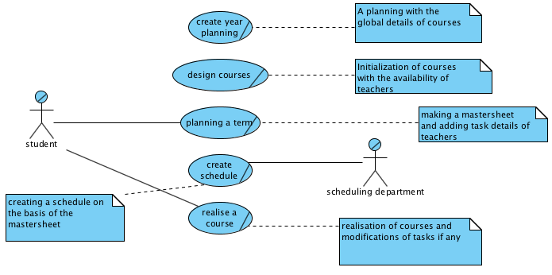

# Chosen Business Process

## Business Use Case Specification

|  |  |
| --- | --- |
| *Business use case:* | Planning a term |
| *Business actor:* | Team manager |
| *Business worker(s):* | Scheduling department |
| *80% scenario:* | **Precondition:**  Use case course planning has successfully produced course parameters.  **Scenario:**  The team manager consults the teachers to gather information about their expertises, availability and preferences. The team manager then imports the course parameters, number of enrolled students and year planning into the mastersheet. Then he assigns teachers to tasks and shows a PTO to each teacher for confirmation. If needed, changes can be made to tasks after revision of the PTO by the teacher. Afterwards, the mastersheet is sent to the scheduling department.    **Postcondition:**  Scheduling department has received the detailed mastersheet. |
| *20% scenario:* | **Precondition:**  Use case course planning has successfully produced course parameters.  **Scenario:**  The team manager imports the parameters into the mastersheet, after which teachers are assigned to tasks. This results in an incorrect workload.  **Postcondition:**  The mastersheet has incorrect workload values. The course manager has to revalue the task workload in the course parameter. |

## Business Process Diagram

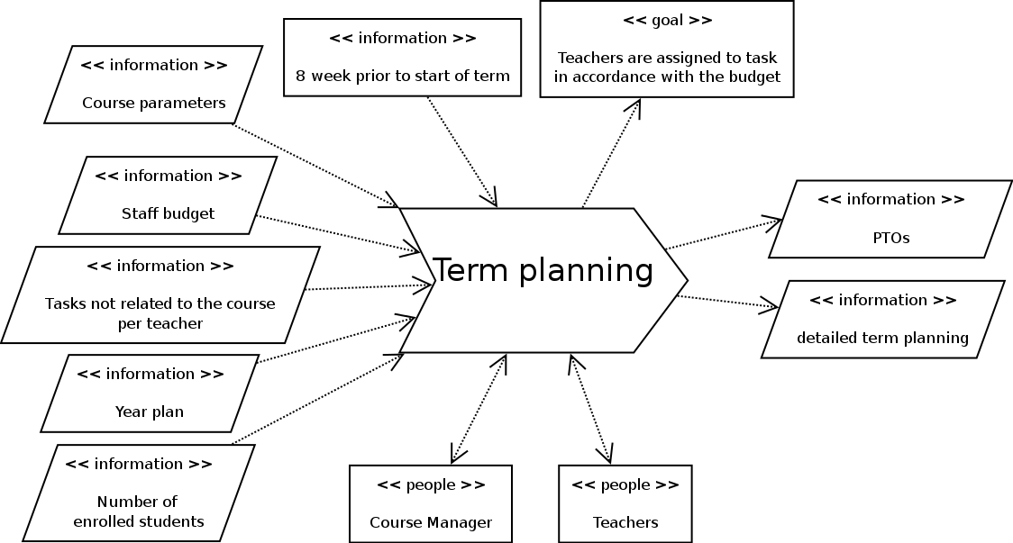

## Business Activity Diagram

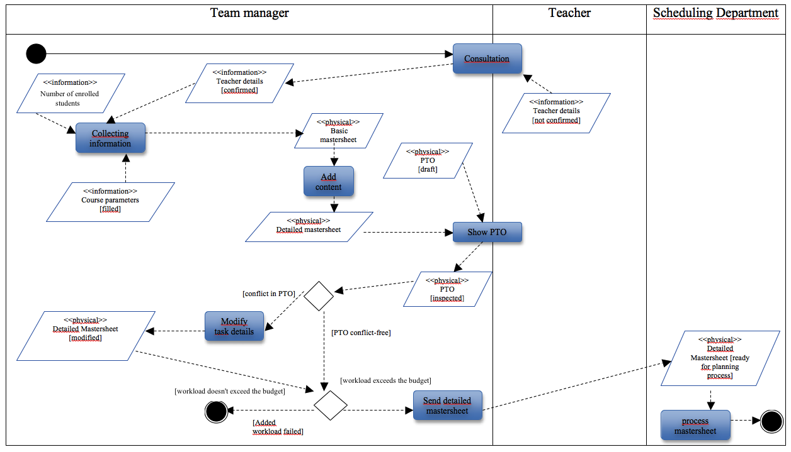

# Business Rules

This chapter contains all rules that defines or limit the business. Desired system needs to adhere to these business rules. They can also be found in the Requirements Discipline document.

|  |  |  |  |
| --- | --- | --- | --- |
| **ID** | **Description** | **Stakeholder** | **Source** |
| **B01** | Fulltime teachers can give lessons during the day and in the evening. | Team manager | CASE |
| **B02** | Teachers specific to part-time students can only teach in the evening. | Team manager | CASE |
| **B03** | In a PTO teacher tasks are inventorised for 10 weeks. | Team manager | CASE |
| **B04** | Assignment of annual tasks to teachers happens in May / June. | Team manager | CASE |
| **B05** | Each teacher is assigned to tasks according to their working hours. | Team manager | CASE |
| **B06** | Budget in hours for the main phase is 15 * 0.6 * number of enrolled students. | Course manager | CASE |
| **B07** | An activity is carried out by one or more teachers. | Scheduling department | CASE |
| **B08** | An activity cannot be divided into sub-activities, due to a limitation of the Iris program. | Scheduling department | CASE |
| **B09** | An activity can be linked to a type of classroom, but this is not a necessity. | Scheduling department | CASE |
| **B10** | An activity must be bound to one or more groups of students. | Scheduling department | CASE |
| **B11** | A group should not be smaller than two students. Groups larger than eight are not allowed. | Scheduling department | CASE |
| **B18** | A group of students follow a specific course during a specific period in time. | Scheduling department | CASE |
| **B12** | A teacher can be only scheduled for an activity on a day or an hour (hours) on the basis of scheduling preferences. | Scheduling department | CASE |
| **B13** | Team managers should make schedule preferences known before the scheduling process begins. | Scheduling department | CASE |
| **B16** | Every room has a specific room type. | Scheduling department | CASE |
| **B17** | A room type describes the most important properties of a specific room. | Scheduling department | CASE |
| **B18** | Each course has a designated term. | Team manager | Interview 17-3 |
| **B19** | A teacher is allowed to see its own PTO. | Team manager | Interview 18-2 |
| **B20** | A team manager is allowed to see everyones PTO. | Team manager | Interview 18-2 |
| **B21** | A teaching unit consists of course specific tasks. | Team manager | Interview 18-2 |